# 11. Validation, Formatting, and Type Conversion

## 11.1 Converting String Values using PropertyEditors

-Record:

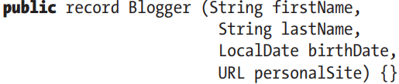

-Spring Configuration with Error:

f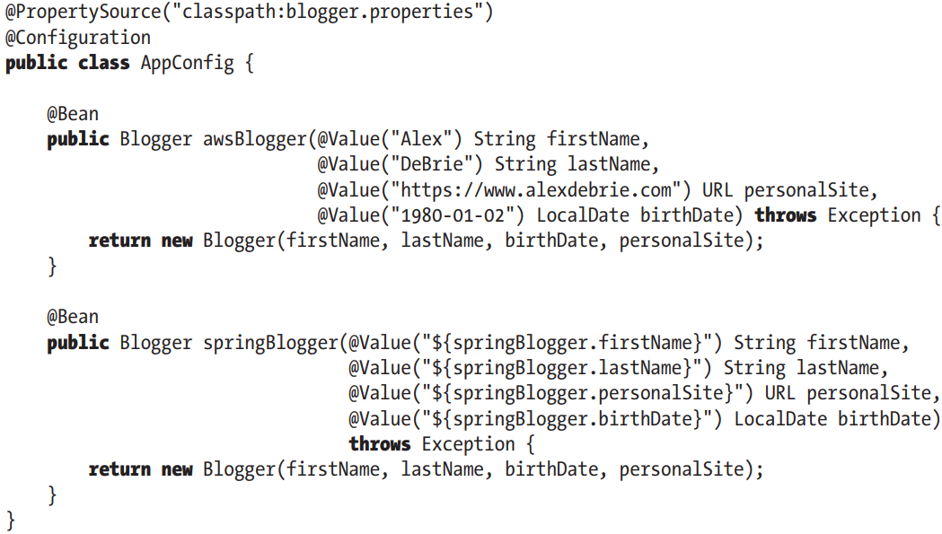

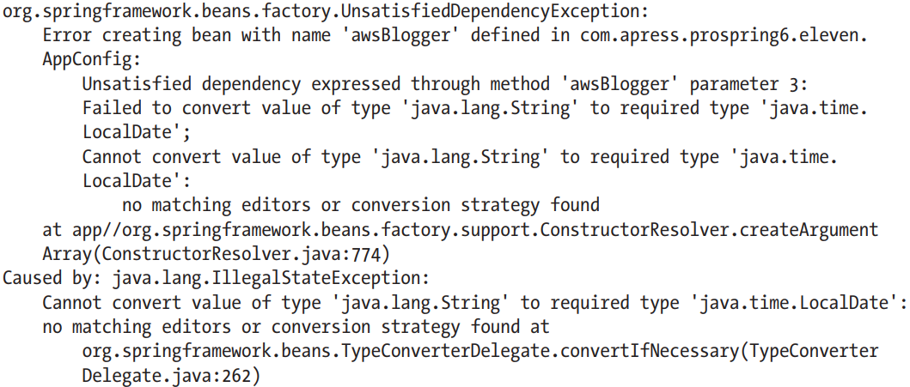

-To fix this, We need to tell Spring how to do the conversion of text representations of calendar dates to LocalDate. We can do by an extension of PropertyEditorSupport:

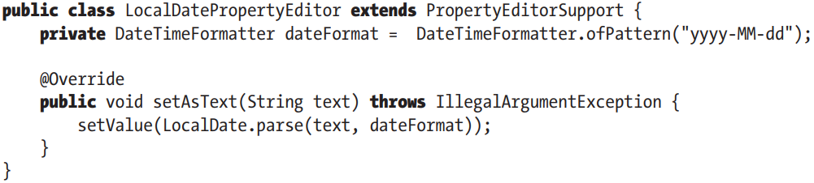

-Registry custom property editor:

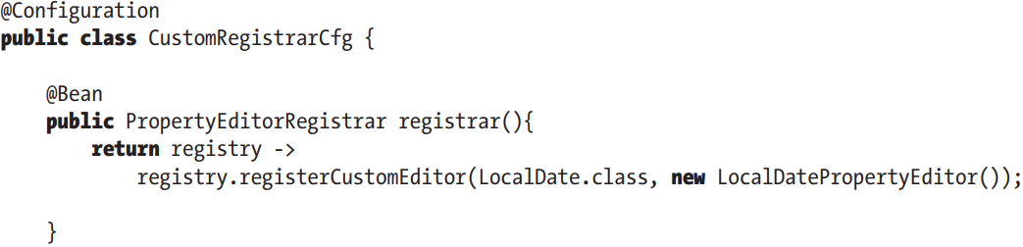

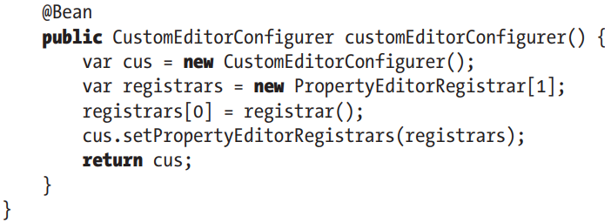

## 11.2 Introduce Spring Type Conversion

### 11.2.1 Implement a Custom Converter

-Implement Converter<S,T>



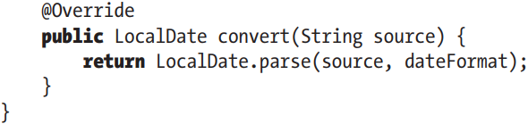

-To use this converter instead of PropertyEditor, we need to configure ConversionService interface:

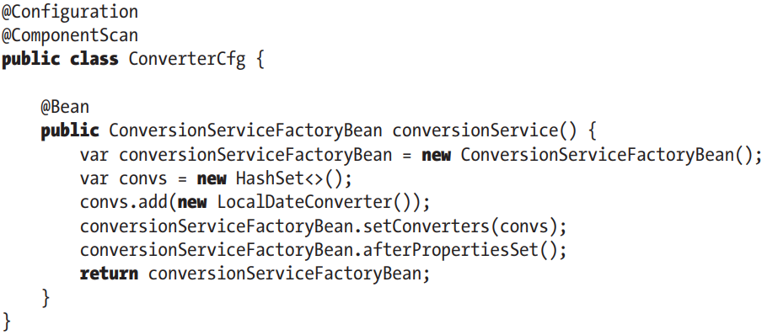

+Declare conversionService bean with class ConversionServiceFactoryBean. This type of bean groups multiple conversion services: if no conversions service bean is defined, Spring will use PropertyEditor-based system.

-By default, type conversion service supports conversions between common types: string, number, enum, collection, map.

### 11.2.2 Converting between Arbitrary Types

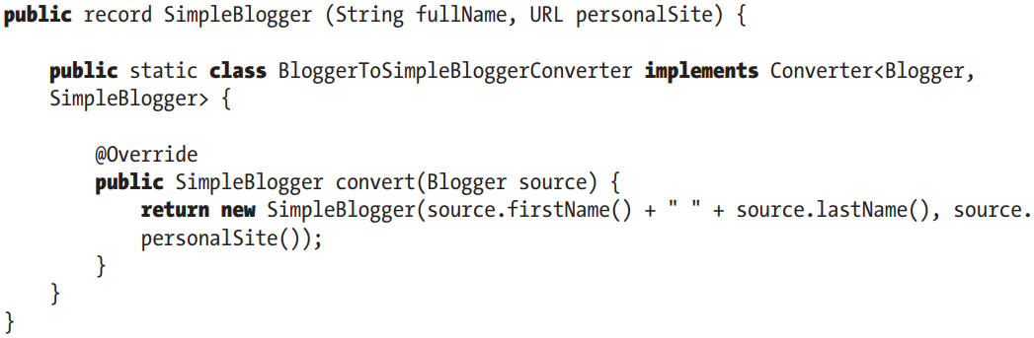

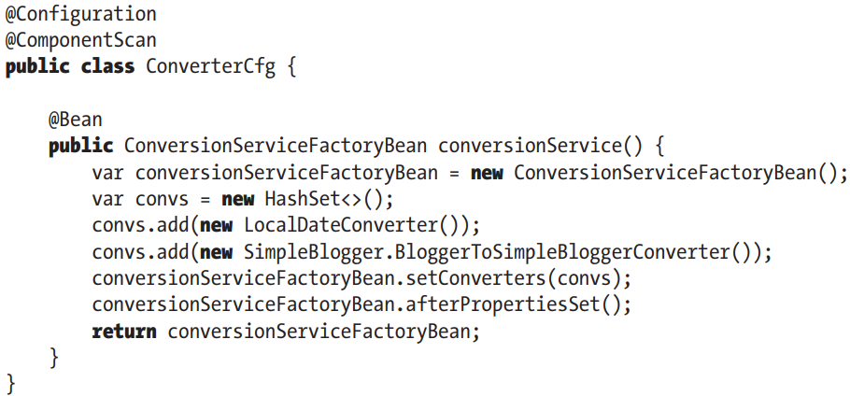

-Spring MVC makes heavy use of conversion service (and Formatter SPI):

+@EnableWebMvc automatically register all default converters (StringToArrayConverter, StringToBooleanConverter, StringToLocaleConverter... in org.springframework.core.convert.support) and formatter (CurrencyStyleFormatter, DataFormatter, AbstractNumberFormatter in org.springframework.format)

## 11.3 Field Formatting in Spring

-Formatter SPI: configure filed-formatting aspects

-The main interface is Formatter<T>. It provides implementations: CurrencyStyleFormatter, DateFormatter, AbstractNumberFormatter, PercentStyleFormatter

-We extend FormattingConversionServiceFactoryBean and provide custom formatter. This is a factory class that provides access to FormattingConversionService

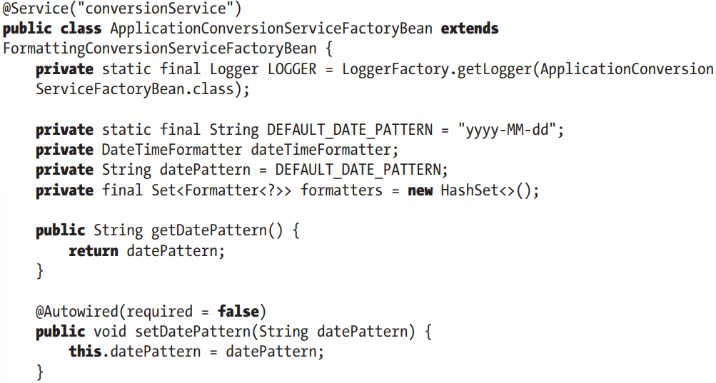

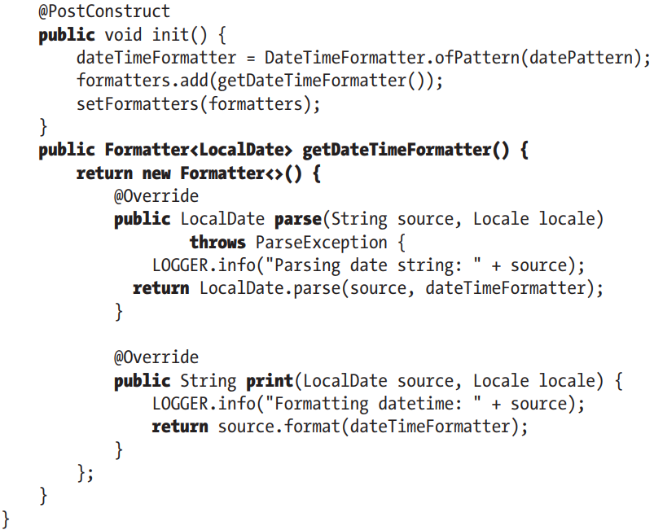

## 11.4 Validation in Spring

-Validation rules applied on domain objects ensure all business data is well structured and fulfills all business definitions.

-The ideal case is that all validation rules are maintained in centralized location, and the same set of rules are applied to same type of data, no matter which source the data comes from.

-**data binding**: extract data from source and perform conversion from sth to desired type. When data binding complete and domain object constructed, validation will be applied to object, and any errors will be returned and displayed to user. If validation succeeds, the object will be persisted to database

-Spring supports 2 main types of validation: Validator interface and via Spring’s support of JSR-349

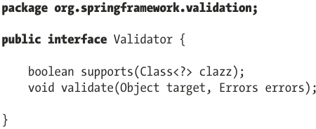

### 11.4.1 Use Spring Validator in Spring

-Implement Validator

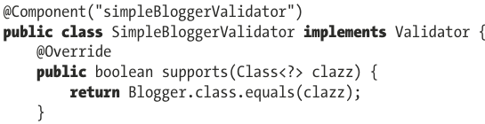

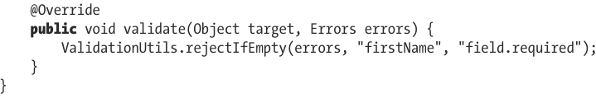

-Note: Converters, formatters and validators are necessary components for applications that handle user-provided data.

-More complex:

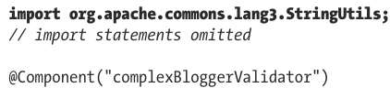

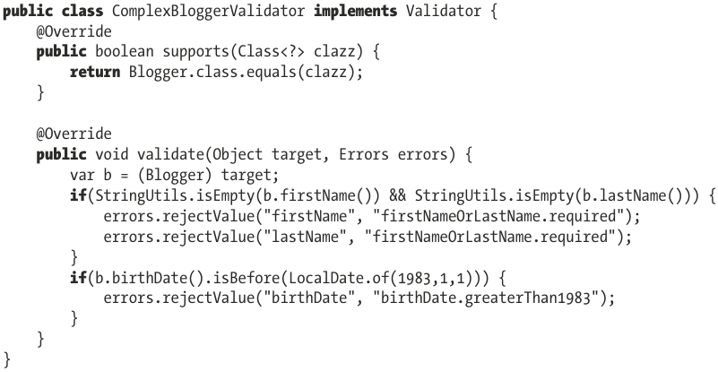

-Validator interface can be implemented to validate complex objects by reusing validation logic for nested objects

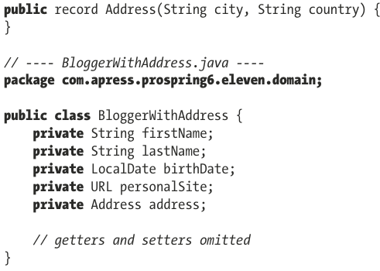

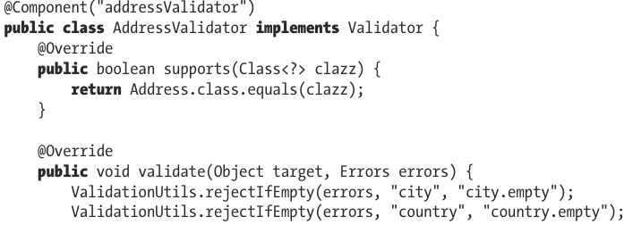

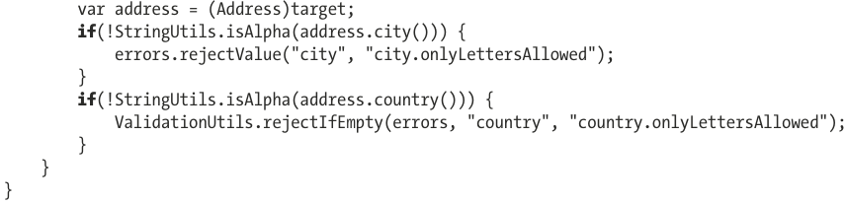

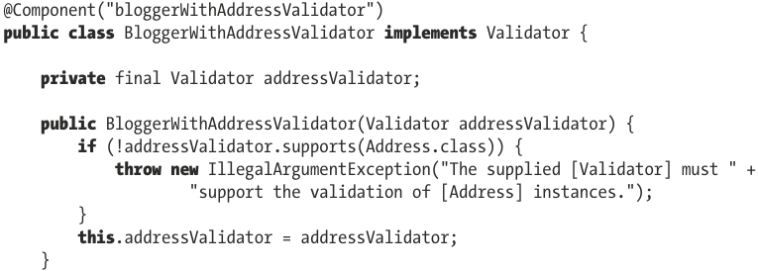

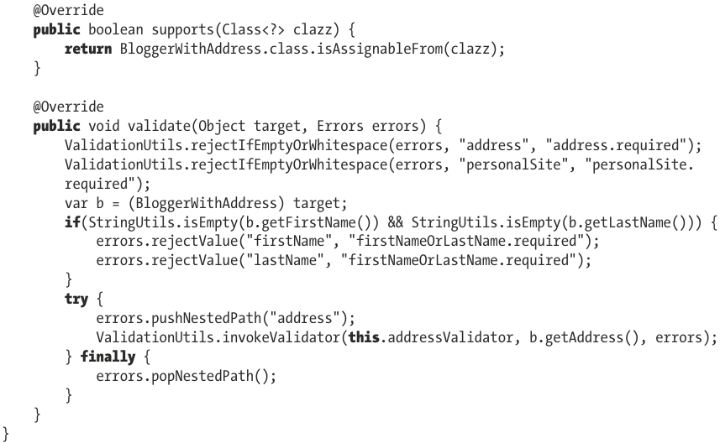

### 11.4.2 Use JSR-349/Jakarta Bean Validation

### 11.4.3 Dependencies

-hibernate-validator

### 11.4.4 Define Validation Constraints on Domain Object Properties

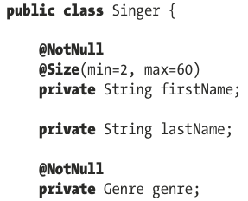

### 11.4.5 Configure Bean Validation Support in Spring

-To configure support of Bean Validation API in ApplicationContext, we define a LocalValidatorFactoryBean, then register all validation services needed.

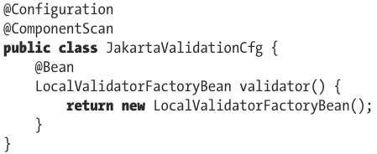

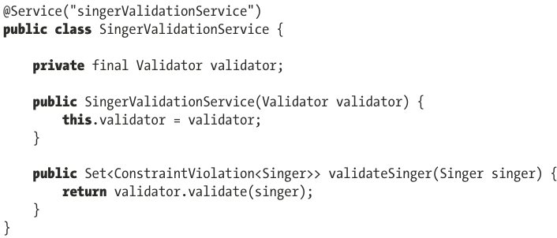

### 11.4.6 Create a Custom Validator

-Annotation interface for Custom Validator

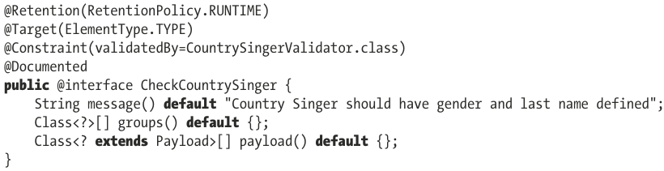

-Validation logic:

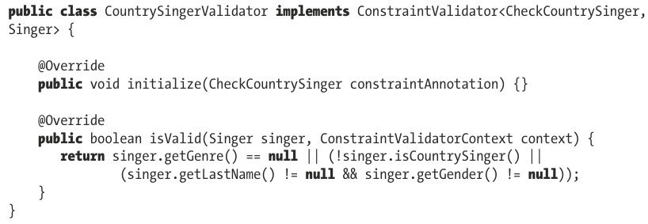

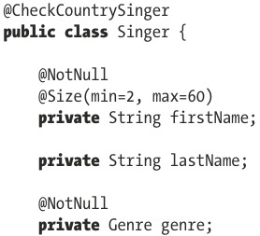

### 11.4.7 Use AssertTrue for Custom Validation

-See in book

### 11.4.8 Decide which Validation API to use

-See in book

### 11.4.9 Configure Validation in Spring Boot App

-spring-boot-starter-validation

# 12. Task Execution and Scheduling

-Task scheduling is composed mainly of 3 parts:

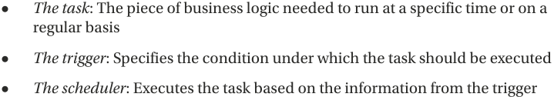

-Java app is described by code that JVM can run on one or multiple threads, and one of threads is non-daemon thread that calls main() of main class.

-In Java, the class to model an execution thread is java.lang.Thread. It can be created by extending this class and overriding run(). The resulting instance models an execution thread must be started by start()

-Another way to create threads: implement **Runnable**. It provides a common protocol for objects that wish to execute code. This means Runnable instances can be created and passed to some components (executors) that execute code in the way they were configured: sequentially, parallel, using threads provided by a thread pool.

-In Java app, a task is any instance of type Runnable

-**Executor** interface represents abstraction for **asynchronous task execution**. In **Spring**, there is an interface that extends this one: **TaskExecutor**. This interface is necessary for backward compatibility with JDK in Spring.

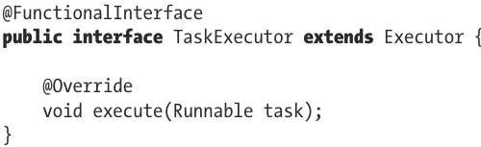

## 12.1 Task Executing in Java

-In Java there are a few Executor implementations.

-**Thread pools** provide improved performance when executing large number of asynchronous tasks. They provide a way of bounding and managing the resources, including threads when executing tasks.

-ThreadPoolExecutor maintains basic statistics as the number of active and completed tasks

-Example: sorting tasks

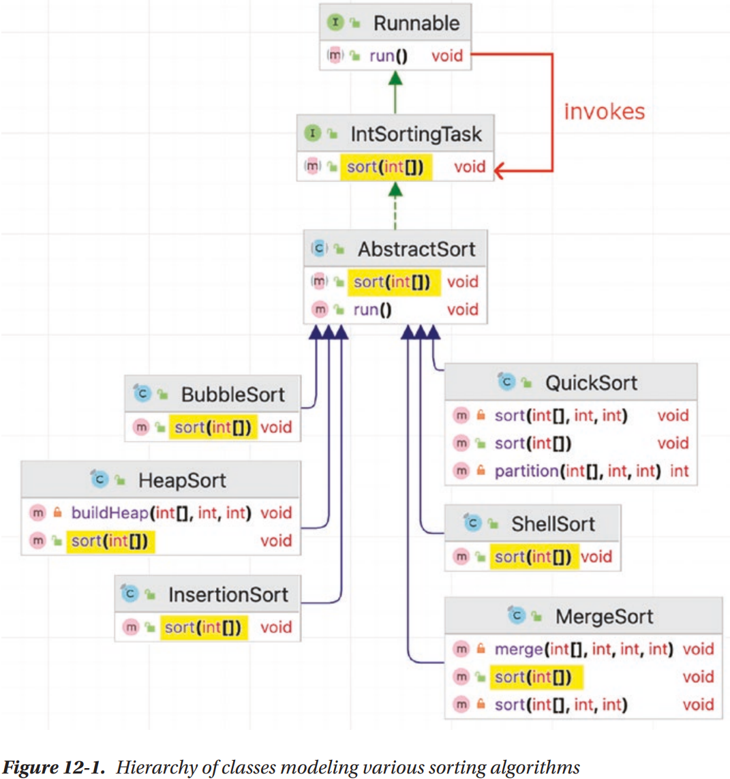

+Running implementation in parallel managed by **ThreadPoolExecutor** instance. This class is an implementation of **ExecutorService** that executes each submitted task using one of several pooled threads, configured using **Executors** factory methods. The **size** of **thread pool** and its **maximum capacity** are provided as **arguments**. The **tasks** are provided as an argument of type that implements **BlockingQueue<Runnable>** interface, which avoid the same task being submitted more than once for execution, by being thread-safe.

+ThreadPoolMonitor is a custom extension of Thread to print statistics for a running ThreadPoolExecutor

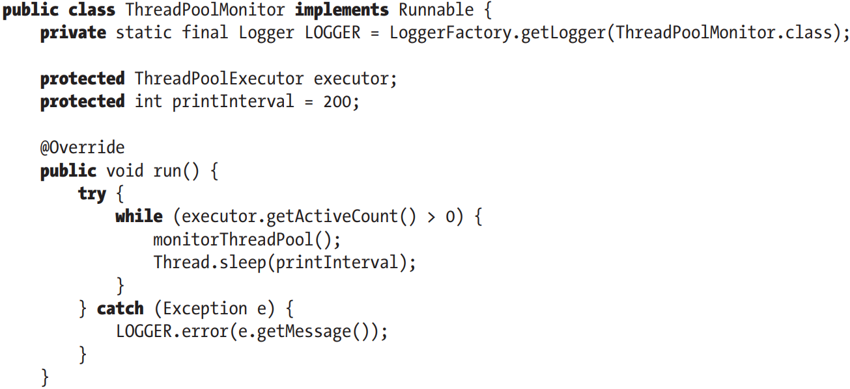

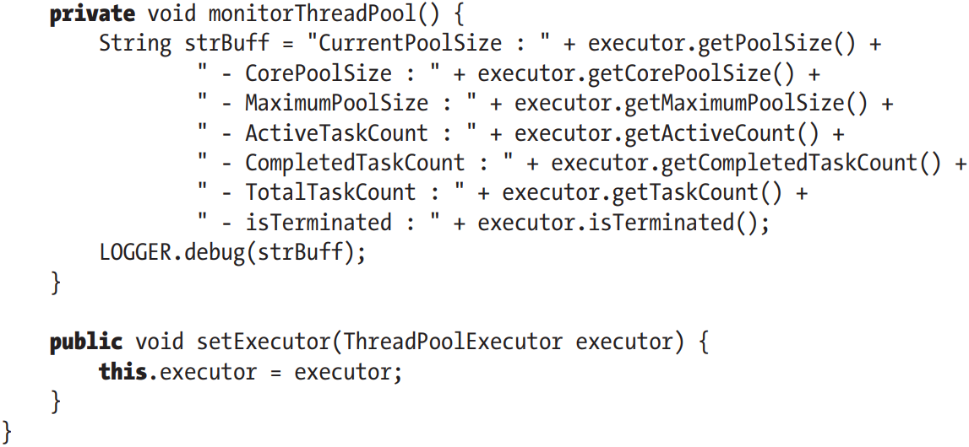

-Example: Generate array containing 100000 elements with values between 0 and 500000 that is handed over to be sorted in parallel by tasks. These tasks are managed and executed by a ThreadPoolExecutor instance, which is monitored by ThreadPoolMonitor.

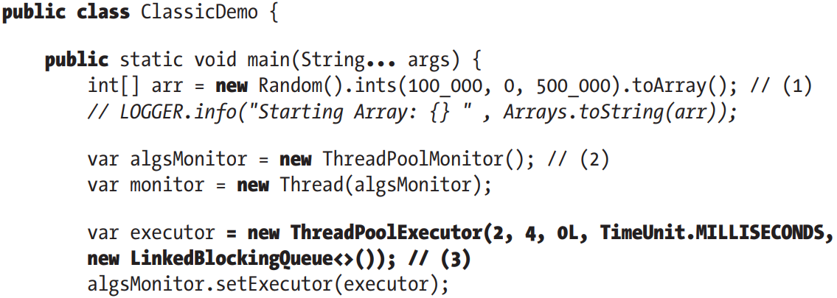

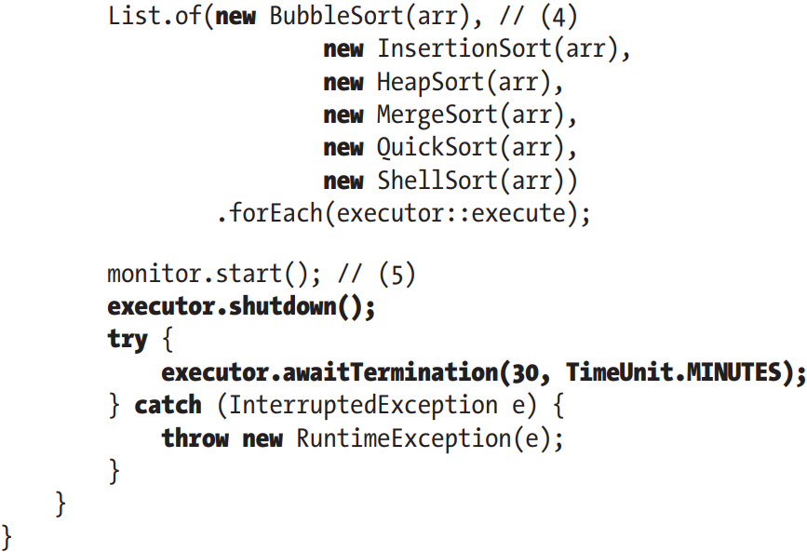

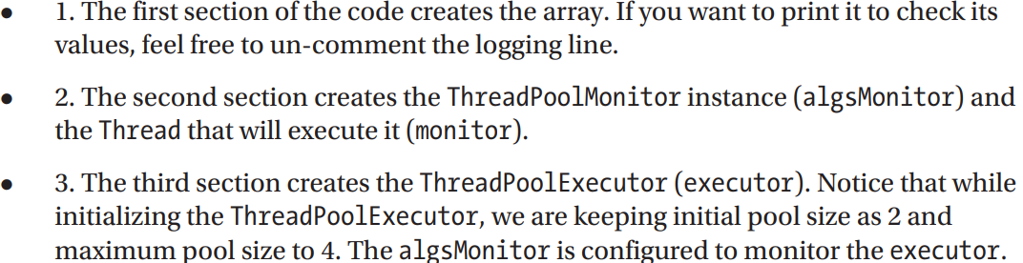

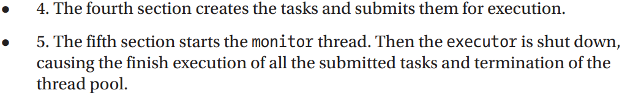

## 12.2 Task Executing in Spring

-Spring’s **TaskExecutor** interface.

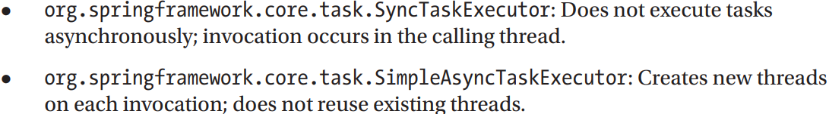

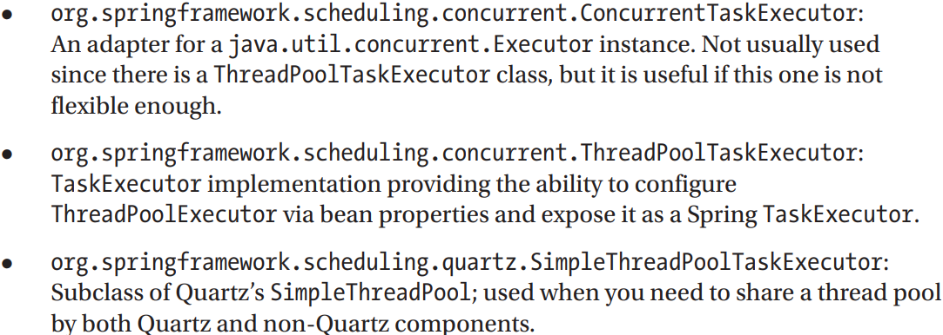

-Example:

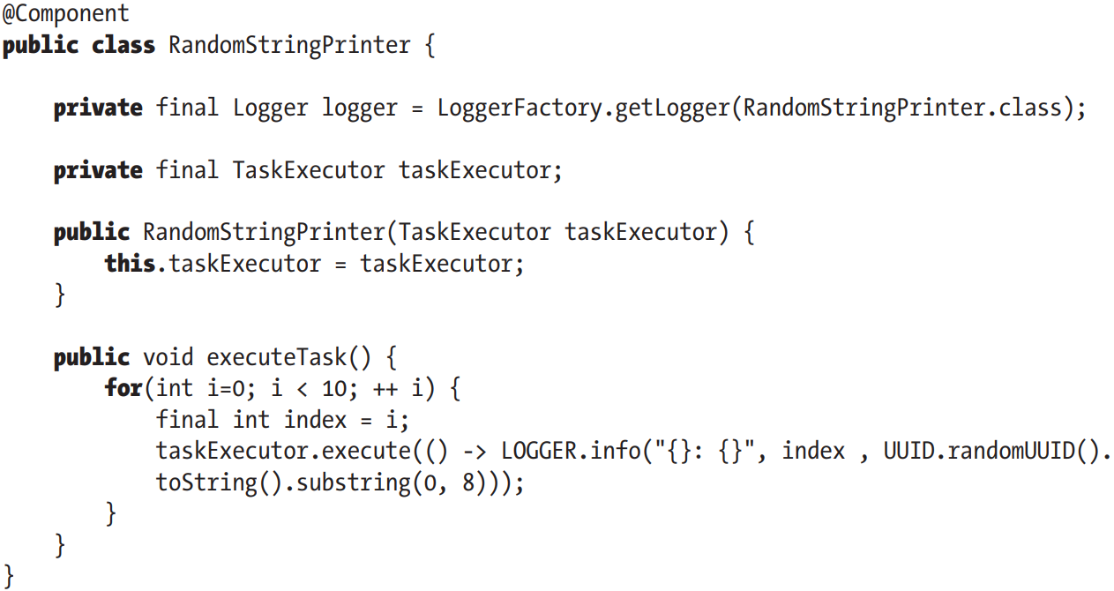

+Provide a declaration for TaskExecutor bean:

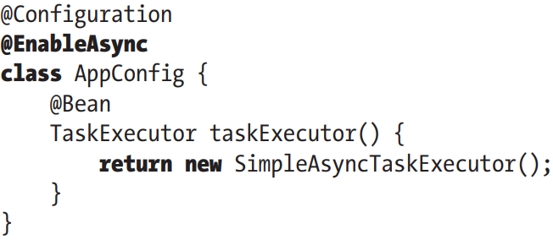

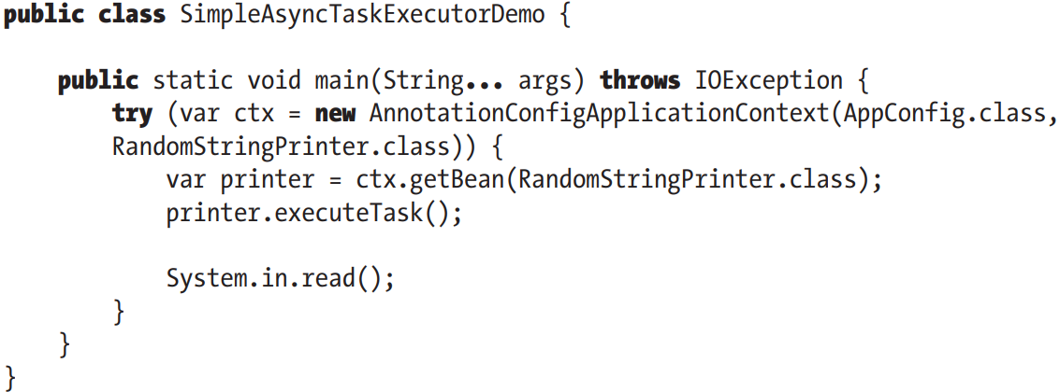

**+@EnableAsync**: enables Spring’s asynchronous method execution capability. Spring will search for an associated thread pool definition: a unique TaskExecutor bean in context or Executor bean named taskExecutor. If none is found, SimpleAsyncTaskExecutor will be used to process async method invocations.

## 12.3 Task Scheduling in Spring

-There are many ways to trigger the execution of a task in Spring app. One way is to trigger a job externally from a scheduling system that already exists in application deployment environments. Example: commercial system (Control-M, CA AutoSys), Linux/Unix platform (crontab scheduler). The job triggering can be done by sending a RESTful-WS request to Spring and having Spring MVC controller trigger the task.

-Another way is **task scheduling support**. Spring provides 3 options of task scheduling:

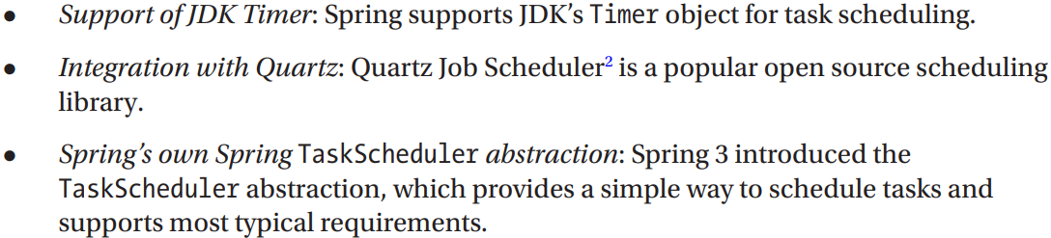

### 12.3.1 Introduce Spring TaskScheduler Abstraction

-TaskScheduler abstraction provides methods for scheduling tasks to run at some point and has 3 participants:

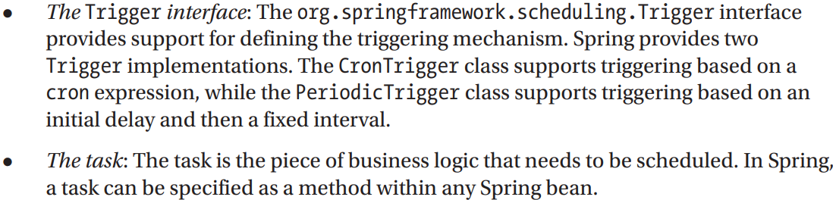

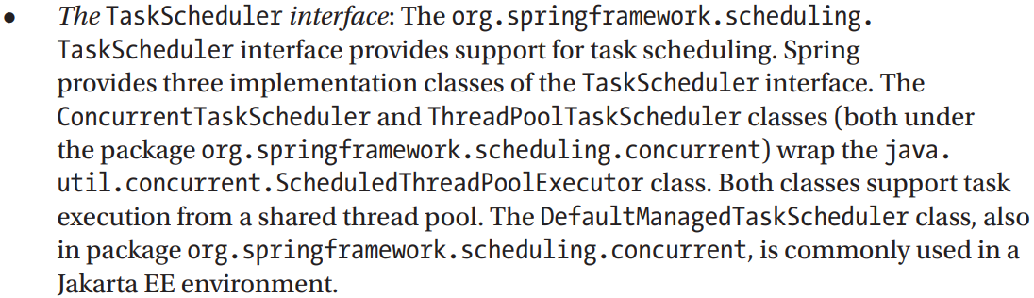

-Relationship between Trigger, TaskScheduler and task that implement Runnable:

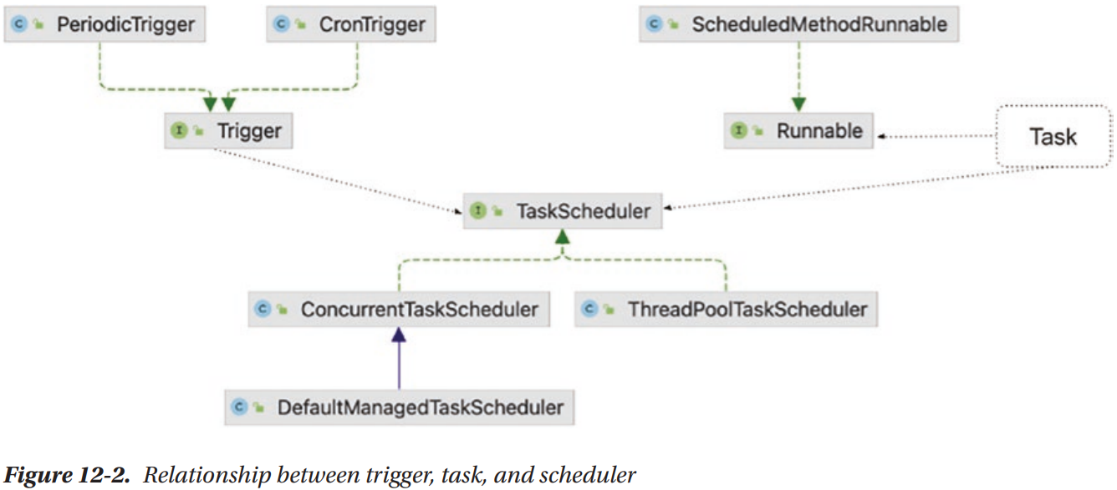

### 12.3.2 Explore a Sample Task

-Service:

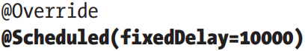

-Configuration enable task scheduling:

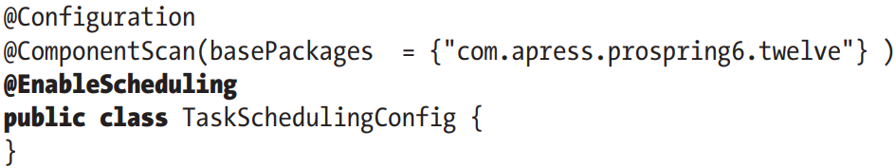

**-@EnableScheduling**: enable detection of @Scheduled on any bean. This annotation look for: unique TaskScheduler bean in context or a TaskScheduler bean named taskScheduler or a ScheduledExecutorService bean. If none is found, a local single-threaded default scheduler will be created an used to execute scheduled tasks.

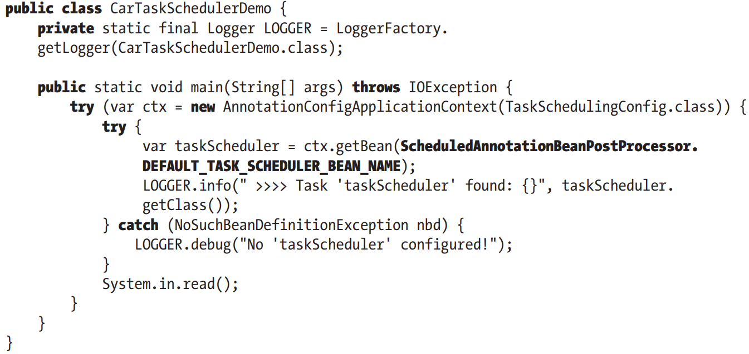

+We search for scheduler bean named taskScheduler (value of DEFAULT_TASK_SCHEDULER_BEAN_NAME)

-Scheduling task in Spring is implemented by **proxying**. @EnableScheduling adds SheduledAnnotationBeanPostProcessor to context that picks up @Scheduled methods. These methods are invoked by TaskSheduler according to fixedRate, fixedDelay, cron.. @Scheduled methods are executed in a thread pool.

-2 ways to **configure a task scheduler**: make TaskSchedulingConfig class **implement** **SchedulingConfigurer** and **override configureTasks()** to set up a custom task scheduler, or **declare** a **TaskScheduler** custom **bean**.

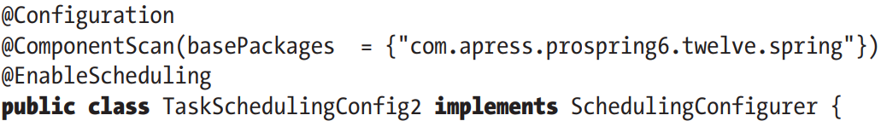

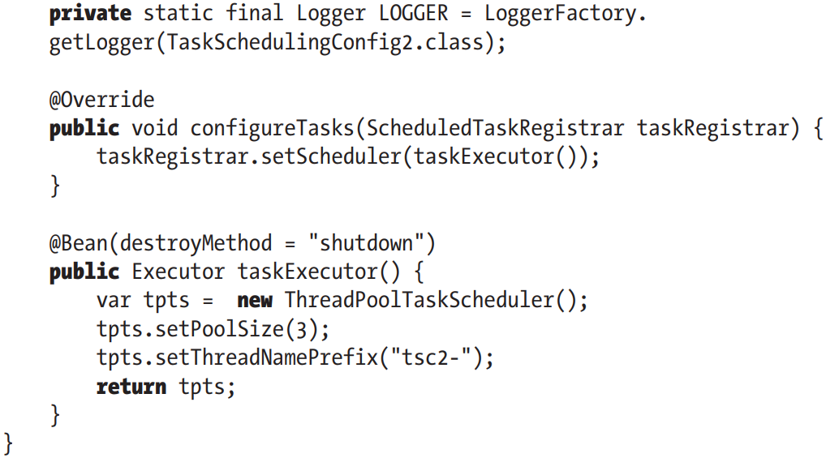

+Declare TaskScheduler bean directly:

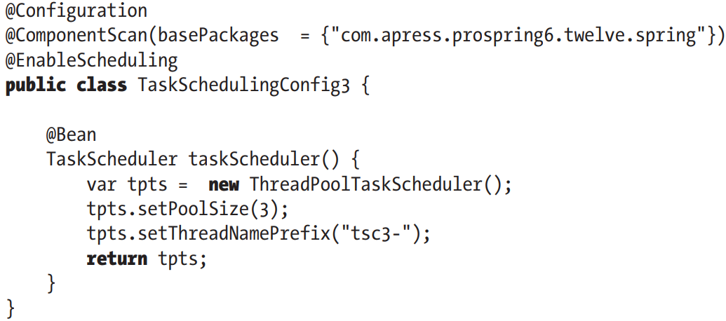

### 12.3.3 Asynchronous Task Execution in Spring

-@Async: Caller returns immediately which actual execution happens in a task submitted to TaskExecutor

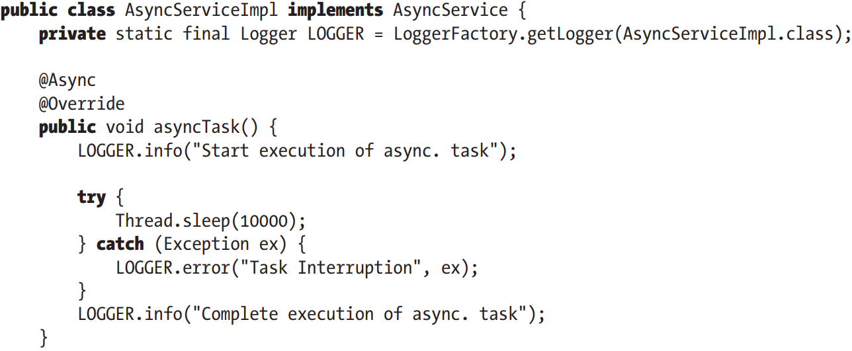

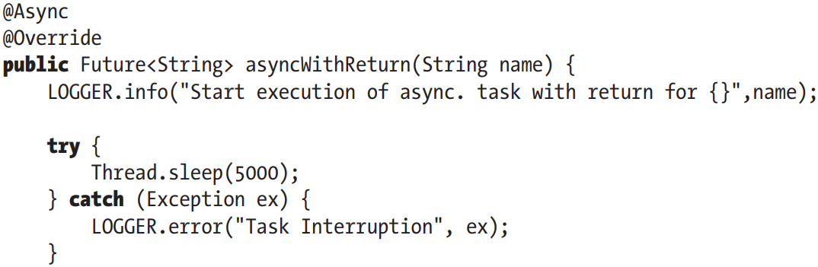

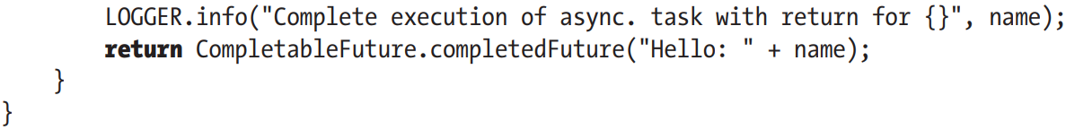

-@EnableAsync: enable asynchronous methods

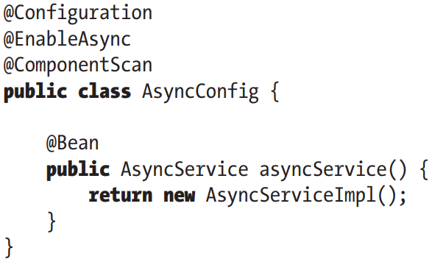

-Customize async configuration: implement **AsyncConfigurer** and override **getAsyncExecutor()**:

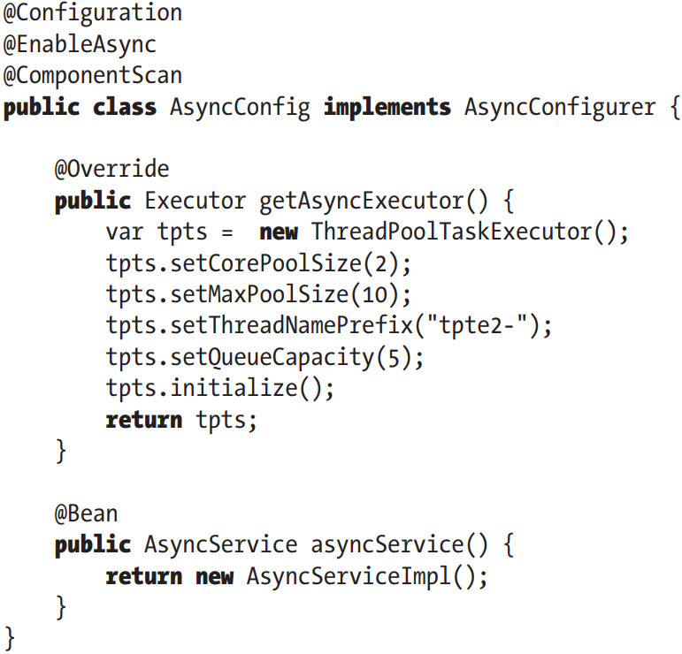

-If more than one task executor is configured, tasks can be assigned to a specific executor: @Async(“otherExecutor)

-Both task executions and schedulers can be configured to handle situations in which tasks end with an exception being thrown using special exception handlers.

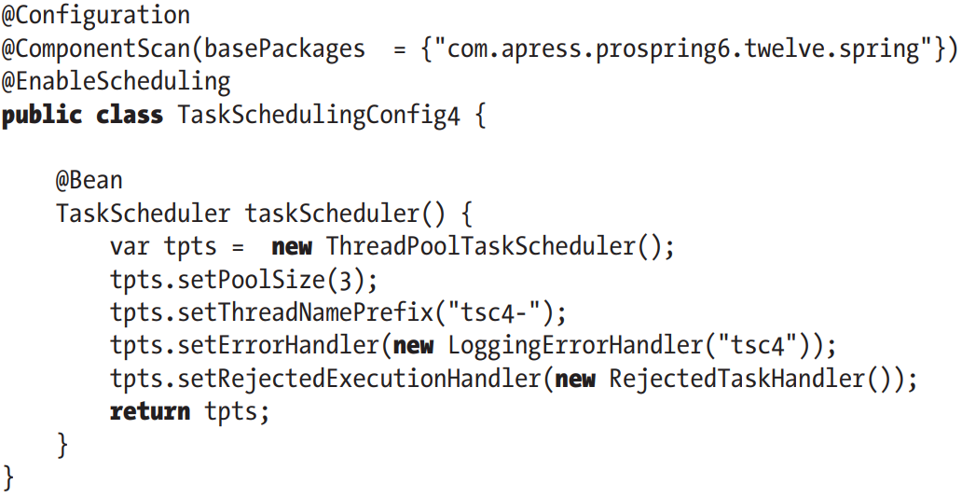

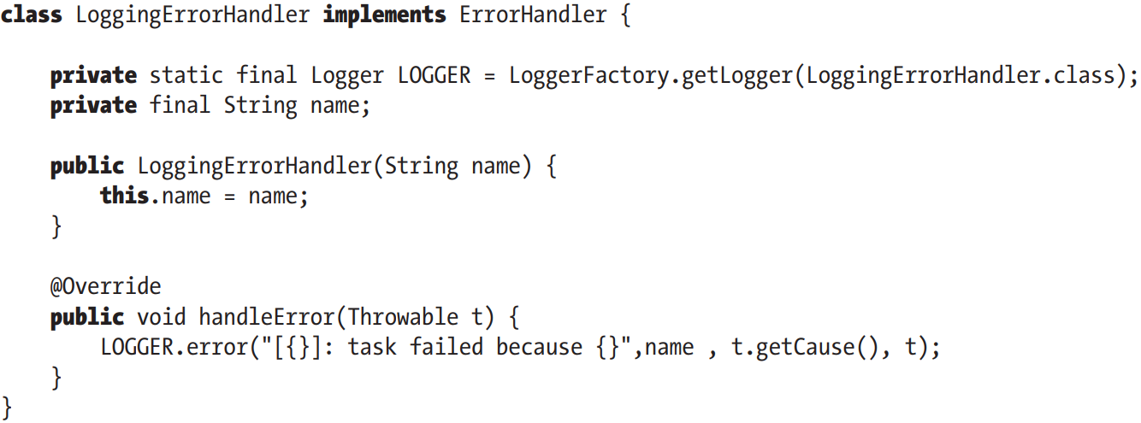

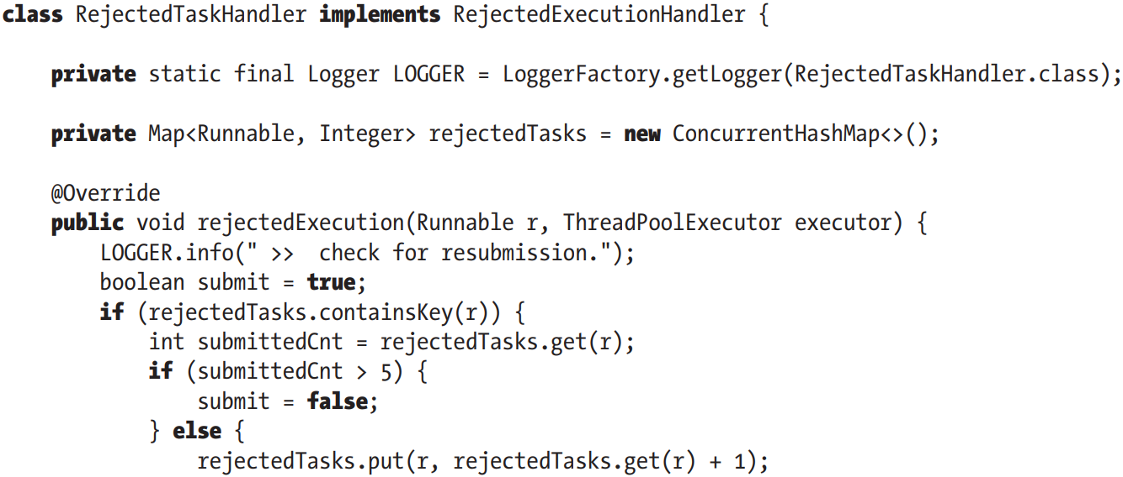

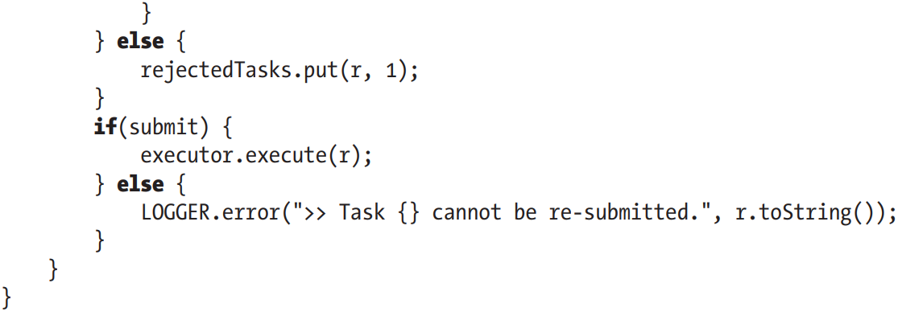

-For a Spring asynchronous task executor, default bean is SimpleAsyncUncaughtExceptionHanlder simply logs the execution. To override this behavior, implement AsyncUncaughtExceptionHandler and override the default one by implementing getAsyncUncaughtExceptionHandler() from AsyncConfigurer

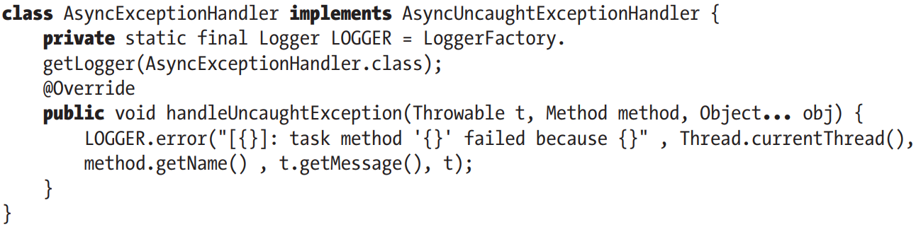

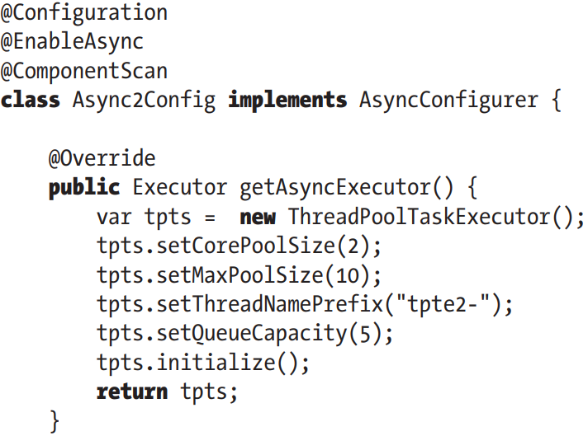

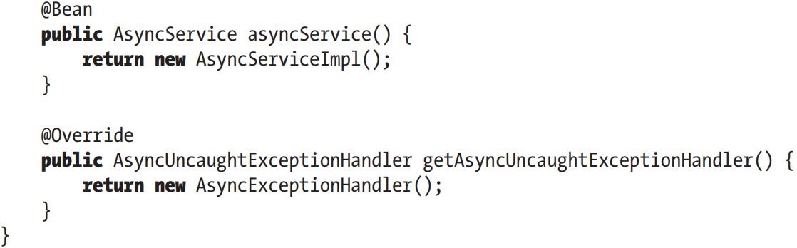

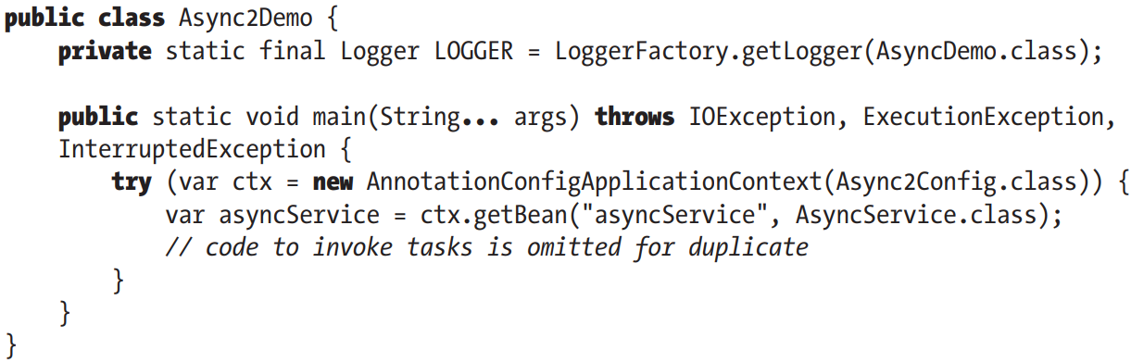

# 13. Spring Remoting

-Simple project: run on a single VM and only component exchange data with database. These types of applications are monolithic applications, inter-process communication

-Enterprise applications are composed of multiple parts and communicate with other applications. Performing the handshaking between applications to build an efficient business process is always a critical task when architecting and implementing app. As a result, remoting support via various protocols and technologies is needed for an applications was achieved in an enterprise environment.

-In early times, communication between applications to participate was achieved via **remoting** and **web services**.

+Remoting: applications know about each other. A proxy of an application object is created in other application, and this allows to make execution of a foreign (remote) method to look like invocation of local method. In Java, remoting support: EJB and JMS are common choices for inter-application server communication.

+web services: remoting technology that sits on HTTP. JAX-RS , Comet, HTML5 WebSocket…

-Nowadays, most popular application architecture style is microservice, small modules/elements that are independent of each other. Inter-service communication.

-Communication via HTTP can be synchronous ( a service has to wait for another service to complete before it returns) or asynchronous (the service takes the request from 1st service and immediately returns a URL).

-The 2nd communication pattern leveraged in microservice is message-based communication. The most popular protocol for this is Advanced Message Queuing Protocol (AMQP). The services interact via a message broker (Kafka, RabbitMQ, ActiveMQ).

## 13.1 Communication via HTTP using Spring REST

-Using HTTP for communication implies that application have to be web applications or expose some REST API to support those calls.

## 13.2 Use JMS in Spring

-**Message-oriented middleware**: referred to as a **message queue** (MQ) server is another way to support communication between applications. It provide asynchronous and loosely coupled way for application integration.

-In Java, **JMS** is standard for connecting to MQ server for sending or receiving messages.

-An MQ server maintains a list of **queues** and **topics** for applications to connect to for sending and receiving messages:

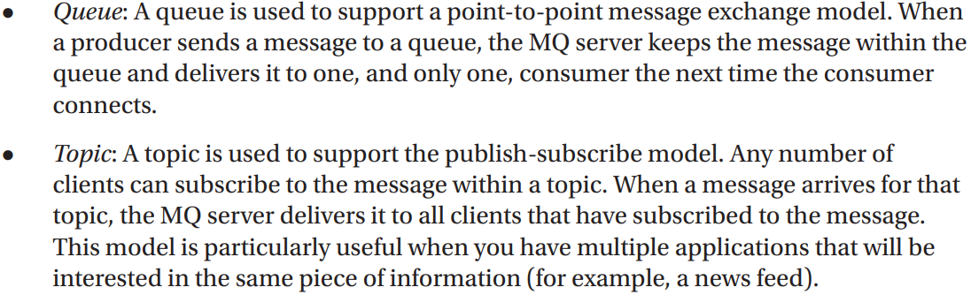

-The core of JMS communication in Spring is **JmsTemplate**

### 13.2.1 Working with Apache ActiveMQ Artemis

-In Spring Boot: it autoconfigures ConnectionFactory bean when it detects ActiveMQ Artemis is available on classpath.

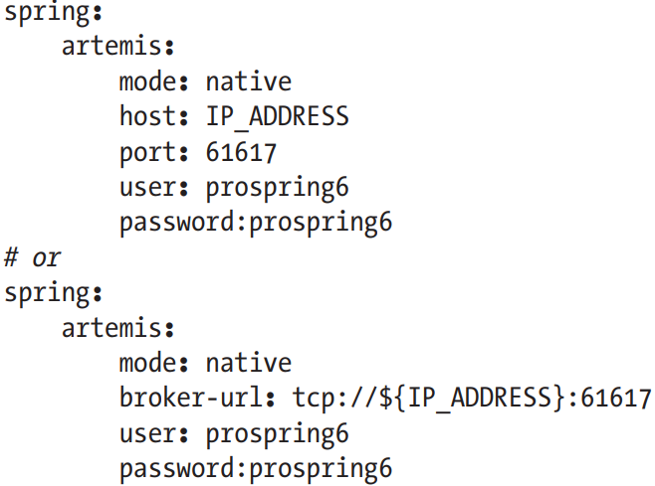

-To use ActiveMQ Artemis embedded in Spring Boot, 3 things: **spring-boot-starter-artemis**, **artemis-jakarta-server** and Spring Boot embedded **configuration**

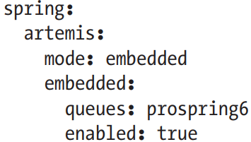

+spring.artemis.embedded.queues: configures a comma-separated list of queues to create on startup

-By default, Spring Boot configures a bean **CachingConnectionFactory** (extension of SingleConnectionFactory): ensures a single JMS connection is opened and shared between all objects needing to communicate with JMS server. It adds caching behavior for message producers and consumers.

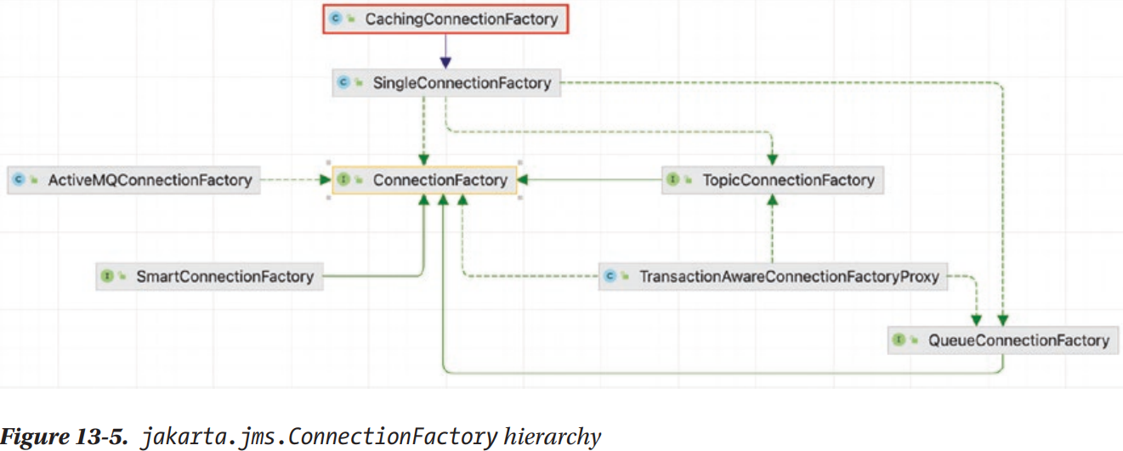

-Spring Boot JMS application abstract schema

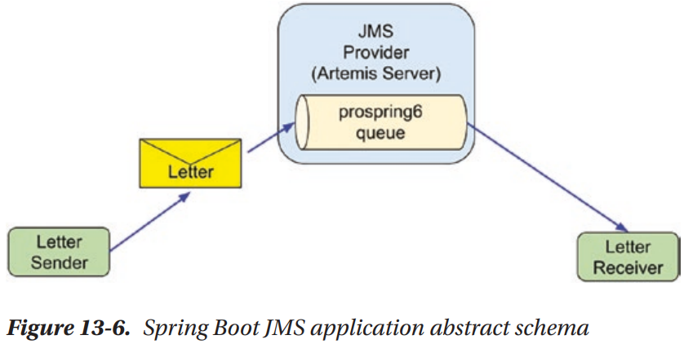

-Letter

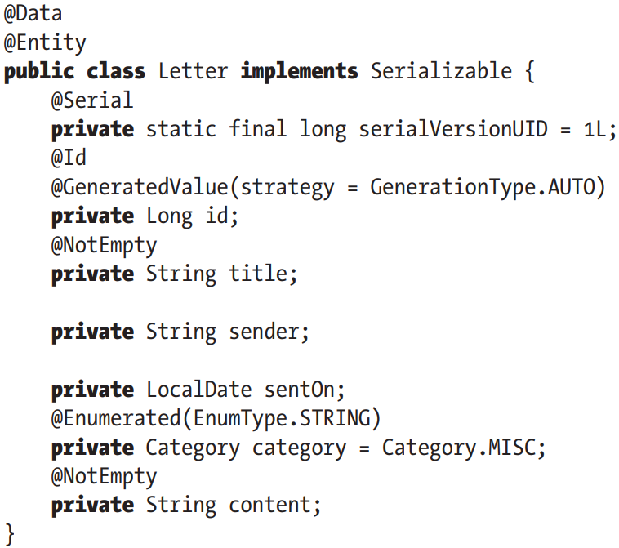

-Sender

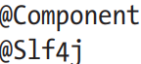

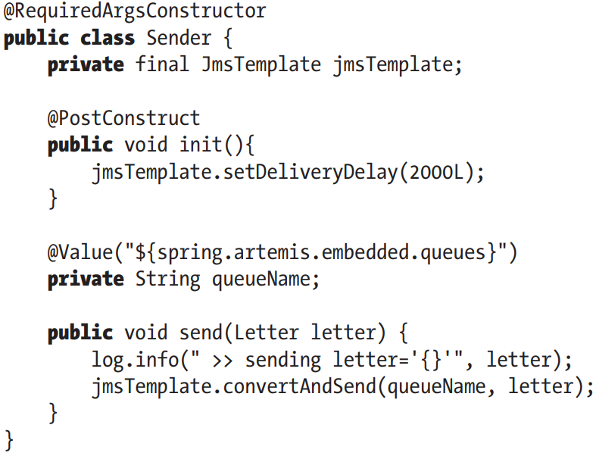

-Category:

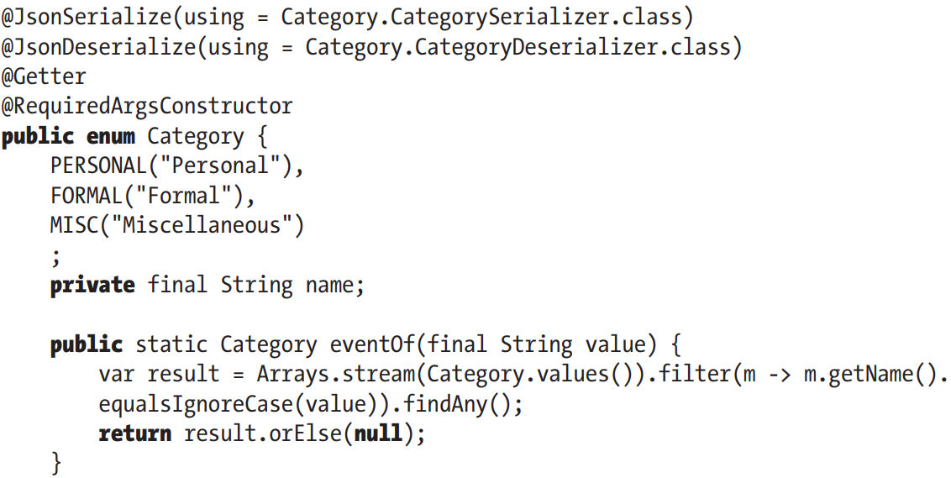

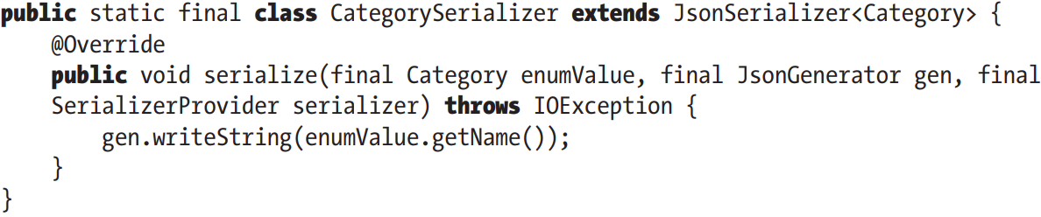

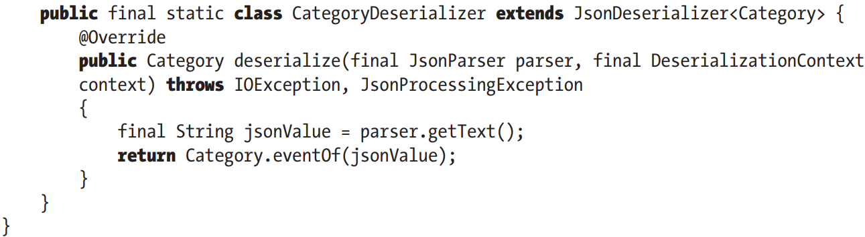

-Receiver:

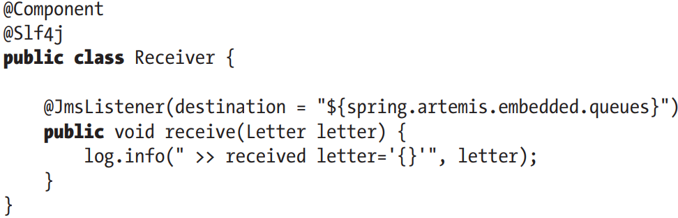

+@JmsListener: mark method to be the target of a JMS message listener on specified destination. This annotation can specify a custom JMS ConnectionFactory using **connectionFactory**. Without it, it uses default ConnectionFactory by SB.

-Processing @JmsListener by JmsListenerAnnotationBeanPostProcessor bean that SB automatically configures. Without SB to configure this bean, use @EnableJms.

-Test:

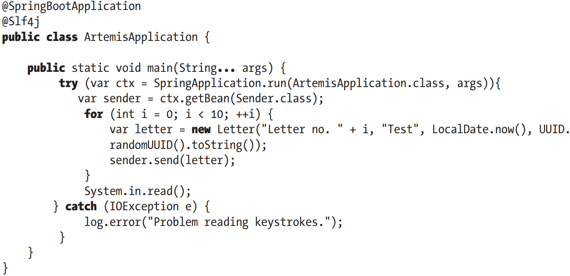

-By default, as the message states, only a few types of message can be written queue, all of them are represented by types implementing Jakarta.jms.Message

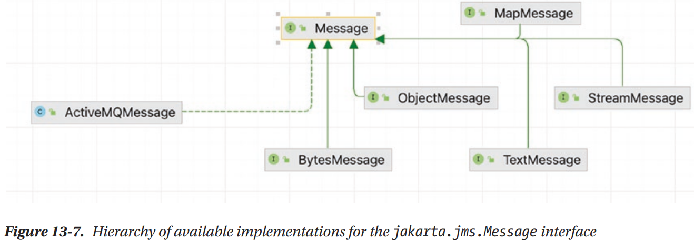

-We need a **message convertor**. The easiest way is to provide a converter that transforms Letter to JSON text representation, so Sender writes Jakarta.jms.TextMessage to queue, and transform JSON to Letter to Receiver. JMS converter is configured using Jackson library:

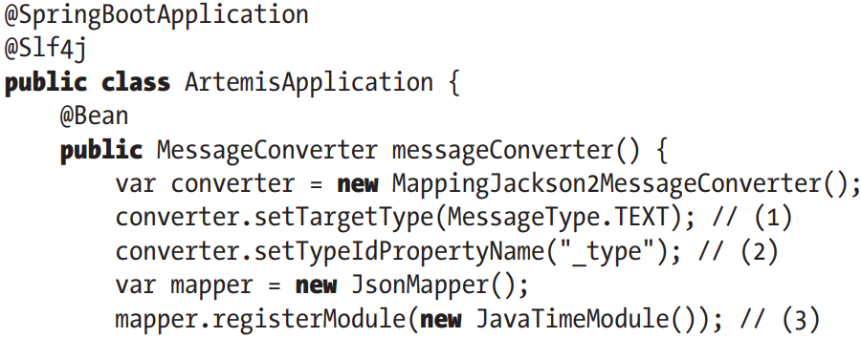

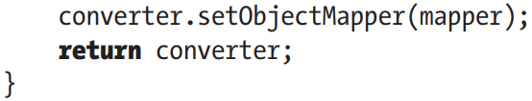

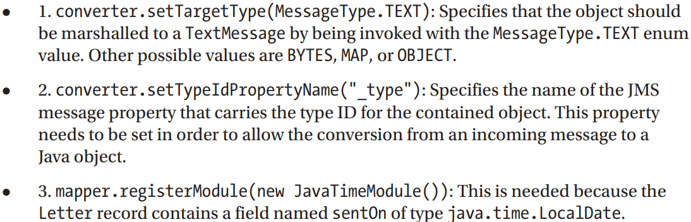

## 13.3 Use Spring for Apache Kafka

-Apache Kafka: a distributed system consisting servers and clients that communicate via a high-performance TCP network protocol. It can be deployed on bare-metal hardware, virtual machine, and containers in cloud environments.

-Containers needed to run Apache Kafka are configured via docker-compose.yaml. This configuration is provided by **Bitnami**

-In production environment, Apache Kafka is run as a cluster, and **ZooKeeper** must manage the instances. Instances of Zookeeper coordinate with each other and each one of them is responsible for its own Apache Kafka server (node).

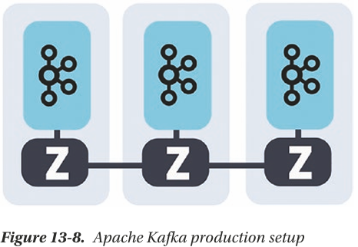

-For development Docker setup, one Zookeeper instance and one Apache Kafka instance.

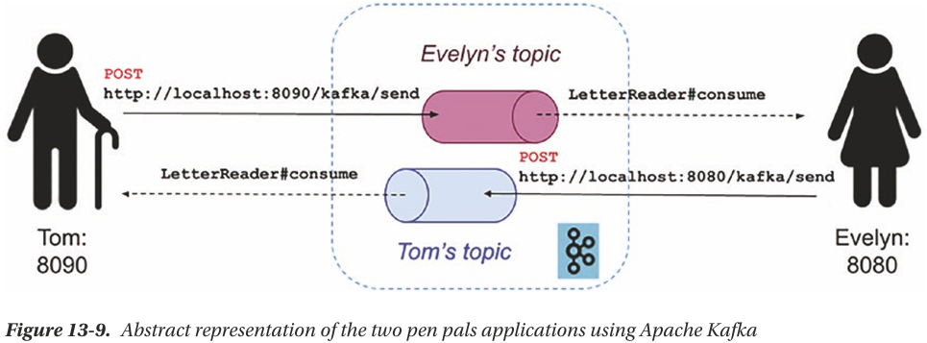

-spring-kafka dependency

-docker-compose.yaml:

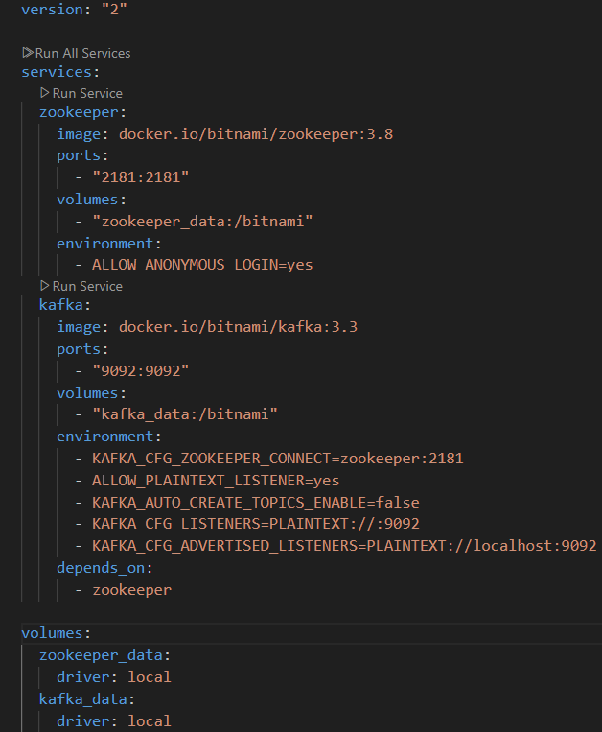

-Configuration

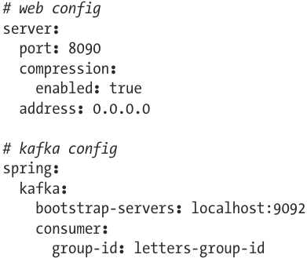 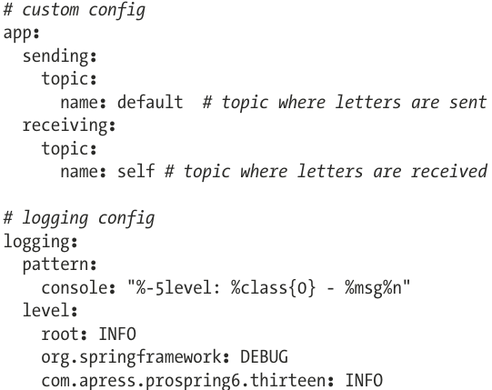

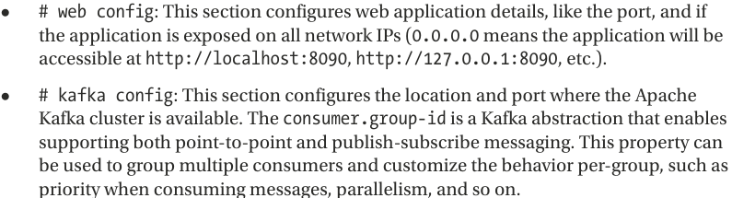

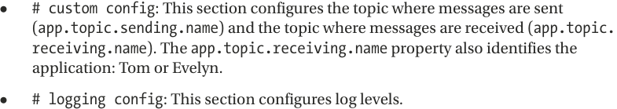

-Letter:

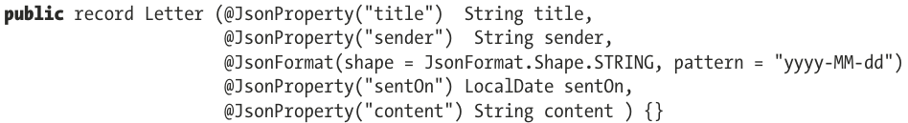

-Kafka configuration:

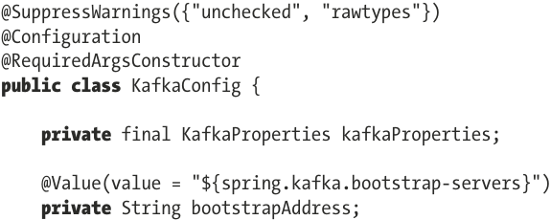

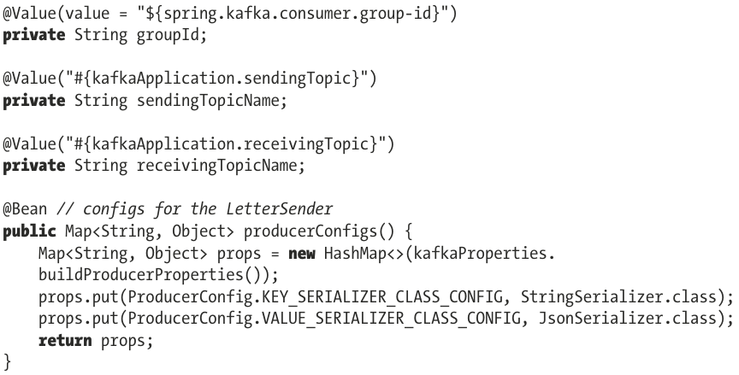

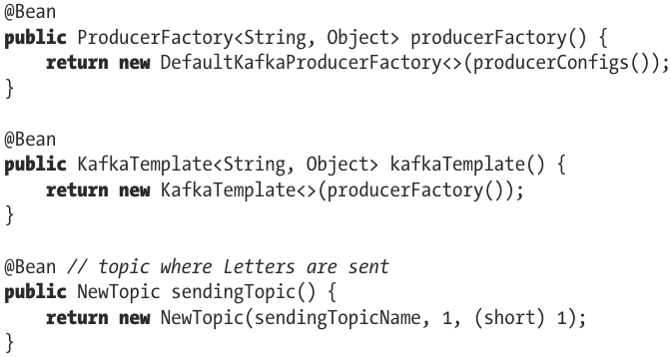

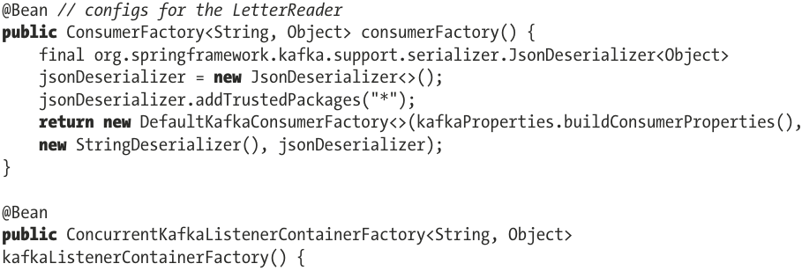

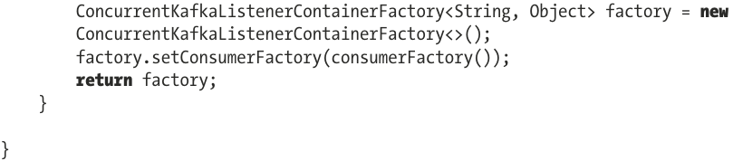

+In Spring Boot, all Kafka-specific properties from configuration are loaded into KafkaProperties bean.

+Serializers and deserializers used to convert Letter to JSON before writing it to topic and vice versa when message is consumed. Letter type is not mentioned: ProducerFactory only needs to know what to use to convert message key and message, because every message has to be identified by key

+NewTopic bean is declared for each topic we need. A topic can be configured to be divided into multiple partitions and replicated across brokers.

+KafkaTemplate similar to JmsTemplate

+ConsumerFactory<K,V> is needed to consume messages from topic. We use Spring’s DefaultKafkaConsumerFactory<K,V> implementation

+For messages to be consumed, they need to be picked up by a listener. Beside @KafkaListener, a ConcurrentKafkaListenerContainerFactory<K,V> is needed.

-Multiple types of messages can be written on the same queue, and read by different listeners, created by ConcurrentKafkaListenerContainerFactory<K,V>

-Message producer LetterSender:

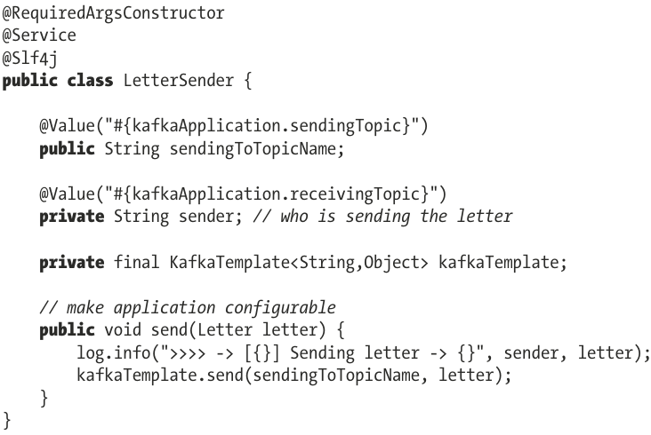

-KafkaController;

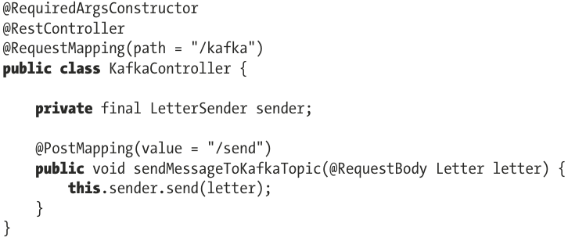

-LetterReader:

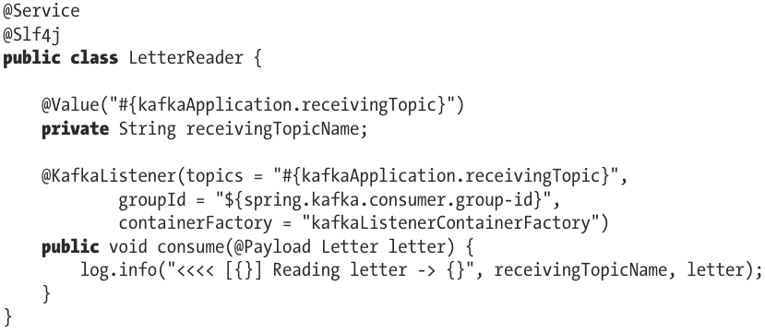

+@KafkaListener: topics to read messages, groupId we want listener to read messages only from a singer group of topics. containerFactory make sure the suitable listener is created.

-KafkaApplication

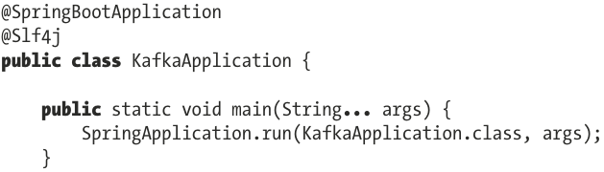  
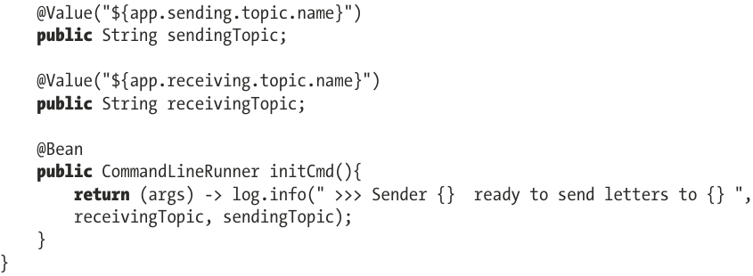

-Start 2 application instances:

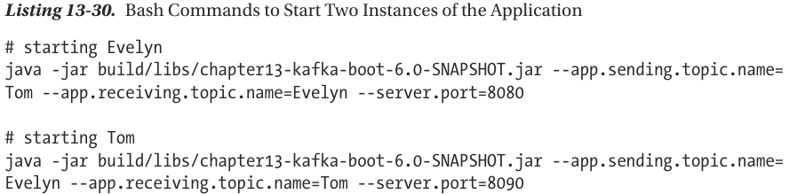

java -jar target/kafka-0.0.1-SNAPSHOT.jar --app.sending.topic.name=Tom --app.receiving.topic.name=Evelyn --server.port=8080

java -jar target/kafka-0.0.1-SNAPSHOT.jar --app.sending.topic.name=Evelyn --app.receiving.topic.name=Tom --server.port=8090

-Send letters test:

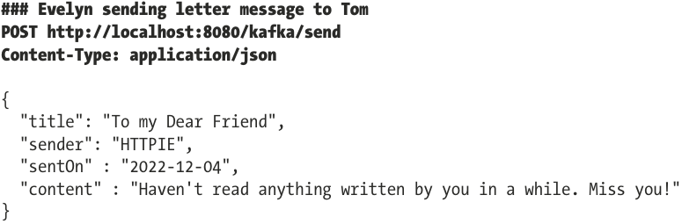

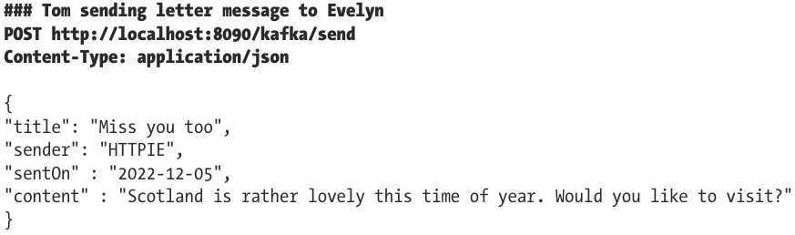

-@KafkaListener can have a different signatures, all details of message can be inspected:

